Preference for Sociopetal Space Scale
- Meagher, B. R., & Marsh, K. L. (2017). Seeking the safety of sociofugal space: Environmental design preferences following social ostracism. Journal of Experimental Social Psychology, 68, 192–199. doi:10.1016/j.jesp.2016.07.004
This scale can be used either as a 6-item bipolar scale or a 12-item Likert scale.

6 Item Bipolar Scale: The following shows the layouts paired on a 6-item bipolar scale, with a large total score indicating a stronger preference for sociopetal space. Items 2, 5 and 6 must be reversed.
Below are a number of different classroom designs. For each pair of pictures you are shown, indicate which of the two classrooms you would prefer to work in right now. Rate how much you like the arrangement of the space in picture a (on the left) versus picture b (on the right) by clicking on the appropriate number from the scale.
1.
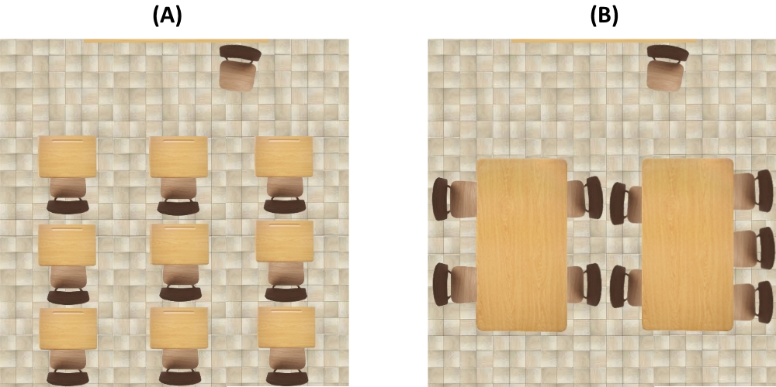

2. (Reversed)
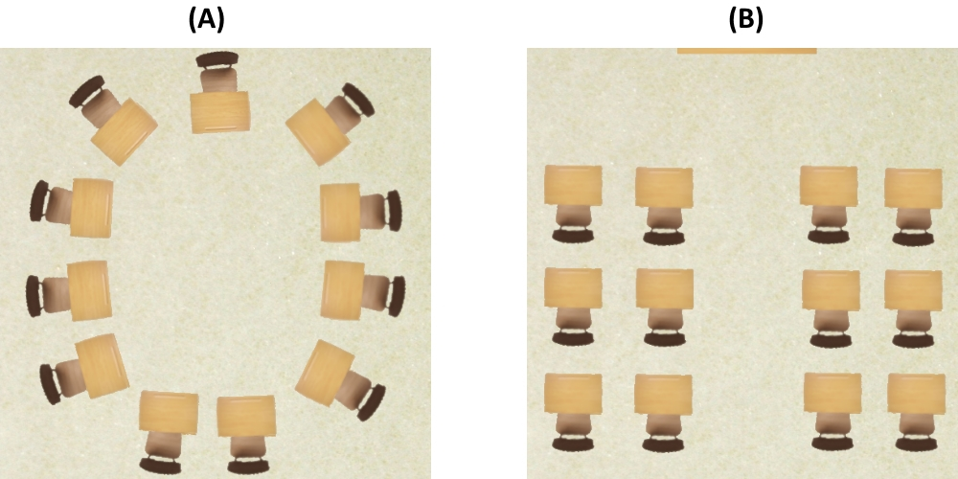
3.
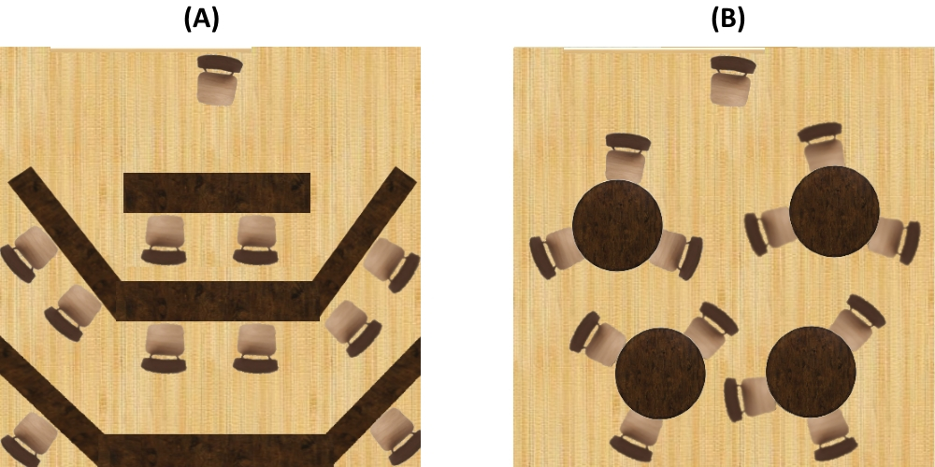
Below are a number of different office designs. For each pair of pictures you are shown, indicate which of the two offices you would prefer to work in right now. Rate how much you like the arrangement of the space in picture a (on the left) versus picture b (on the right) by clicking on the appropriate number from the scale.
4.
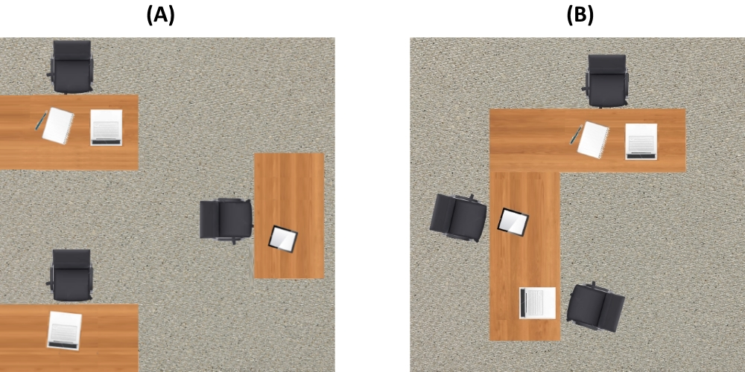

5. (reversed)
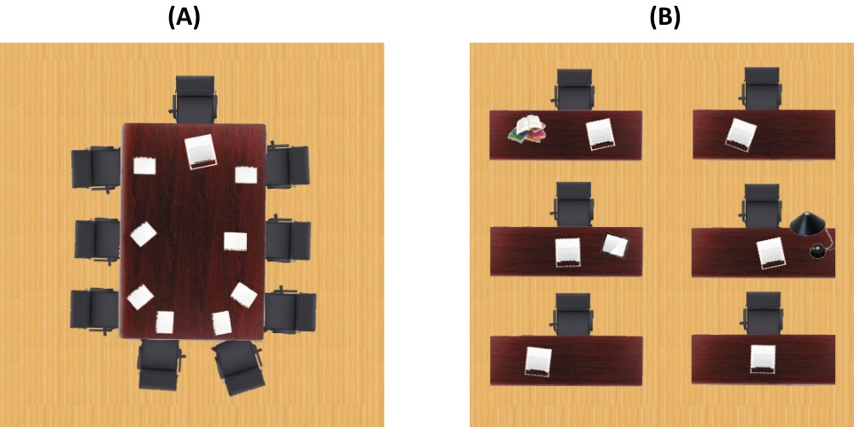
6. (reversed)
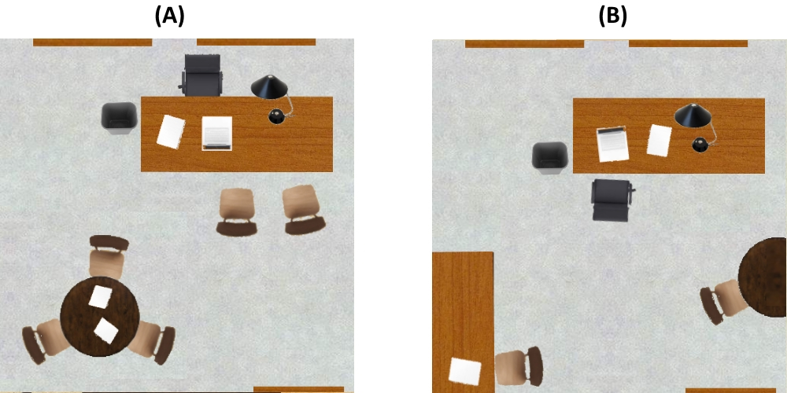
12 Item Likert Scale: Present the layouts individually, rather than paired. Here, items 2, 4, 5, 7, 10, and 12 must be reversed.
1.
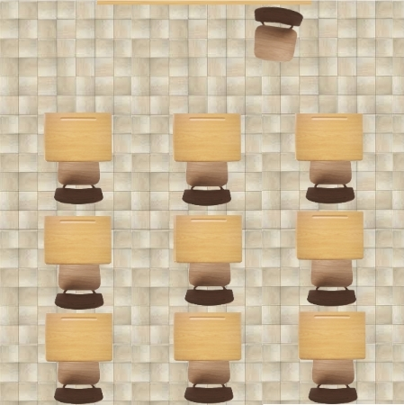
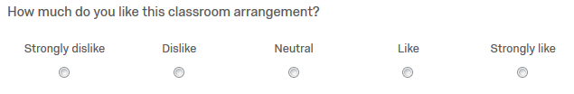
2.
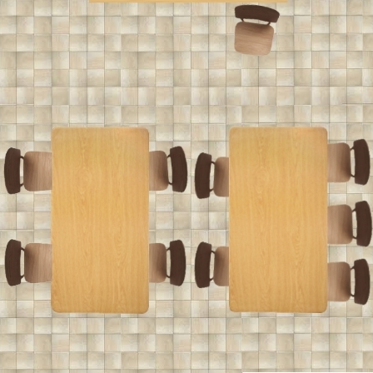
3.
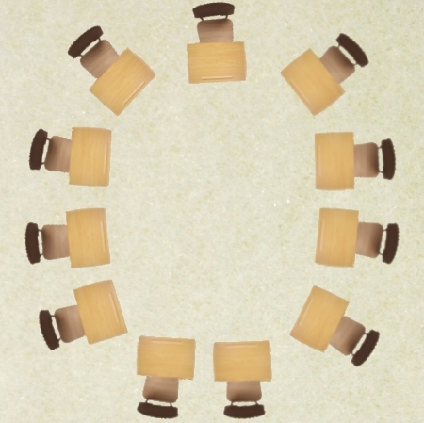
4.
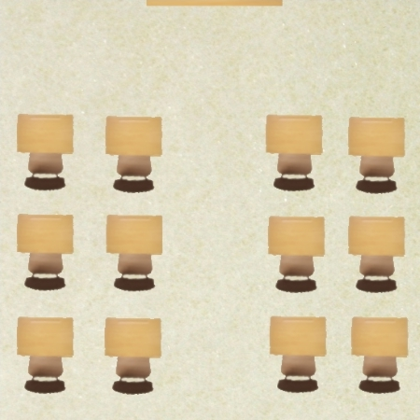

5.
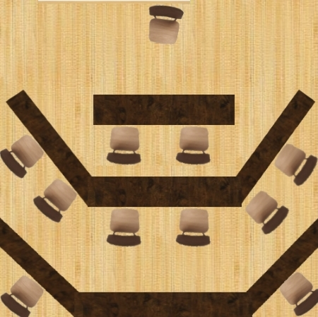
6.
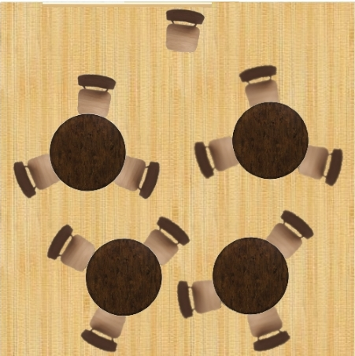

7.
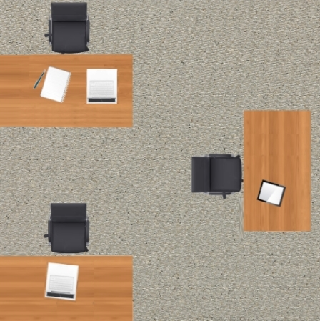
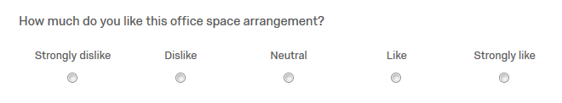
8.
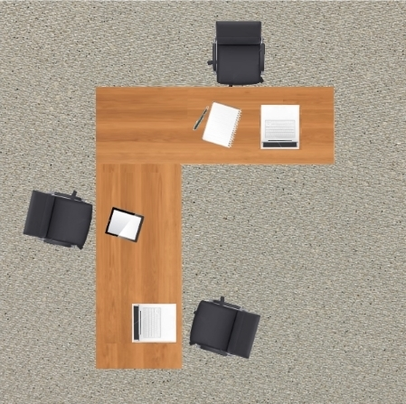
9.
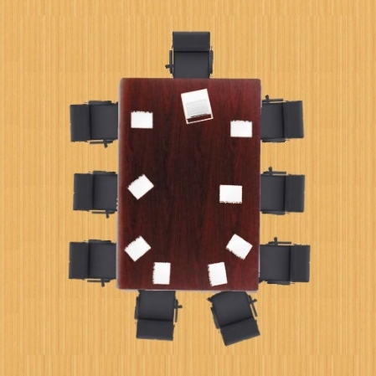
10.
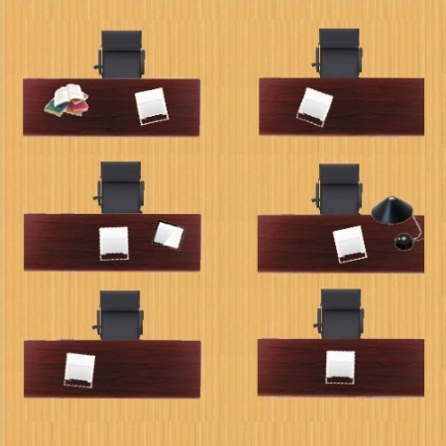

11.
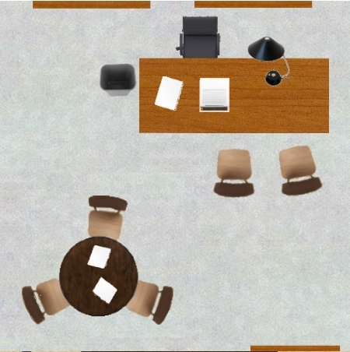
12.
